***Name: Muhammad Sajid***

***Roll No: 2***

***Msc final (Morning)***

**Q1 Morphemes Analysis**

***In linguist morphemes is the smallest possible unit of word that still carrie meaning.***

***Example: if we have the word Dog .***

***And we divide them into smaller piece such is D and og then it has no further meaning and it is not morpheme.***

***If we divide them in such a way that we have Do and g then it is morpheme and it make the word dog.***

If we have the word dogs and hats ( in hats the s has sound of s and it make plural )

It has 2 morpheme dog and s ,here the s has a sound of z and it make the work plural.

Example: En+ courage+ ment = Encouragement

**Type of Morpheme**

*There are different type of morpheme*

***1) FREE MORPHEMES***

***The morphemes that can stand on their own is called free morpheme or we say that free morpheme are those that not attage with other morphemes.***

***Example:***

***Cat. The cat are itself a free morphemes.***

***2) BOUND MORPHEMES***

***The morphemes that must attage with the some another morphemes is called bound morphemes.***

***Example: s if we attage s to the cat then it make it plural such is cats.***

***And it make it bound morphemes.***

*There are two type of Bound morphemes.*

**• Deriavational Morphemes**

**• Inflectional Morphemes**

* *Deriavational Morphemes*

***It is the morphemes which involves the combination of bound morphemes called the ‘ affix ’ and it attage them to create new words.***

***Example: think + re = rethink***

***In the above think has some meaning and ‘re’ are attage with them to make the new word and it has some other meaning.***

* *Inflectional Morphemes*

***It is the second type of bound morphemes in which the morphemes are attage with the word to change the form of the word , and it not effected the semantic of the original word.such is in inflectional morpheme the prefix and suffix are attage to make the inflectional morphemes.***

***Prefix are the morpheme before attaching of an morpheme with them.***

***Suffix are the morpheme after attaching some morpheme with them.***

***Example :***

***Girls has morpheme Girl and s (Girl is itself a single and s are attage with them to make it plural and its form are change)***

***3) Compound Morphemes***

***It the type of morpheme in which free morphemes are attage to make the another morphemes.***

***Example:***

***Dog + house = doghouse***

***Sajid + car = sajidcar***

***Research findings suggest that morphological awareness is the strongest consistent predictor of success for reading comprehension, reading vocabulary, and spelling***

**• Question 3 : How morpheme analysis is better than word analysis.?**

***Morpheme analysis is better than the word analysis ,in a morpheme analysis instruction should teach the students the meaning of the particular morphemes and also it tell the strategy that why they use them. The knowledge of word and morphemes play important rule in the laguastic to learn form the context because user can use and examine unfamiliar word and find the exact meaning of them.***

***The morphemes analysis for the word is better than the word analysis because morphemes provide the strongest predictor consistent for the word for success for reading and understanding of compression, reading and spelling.***

***Morphemes provide the clear understanding and semantic and the word analysis may be umbegious in some case .***

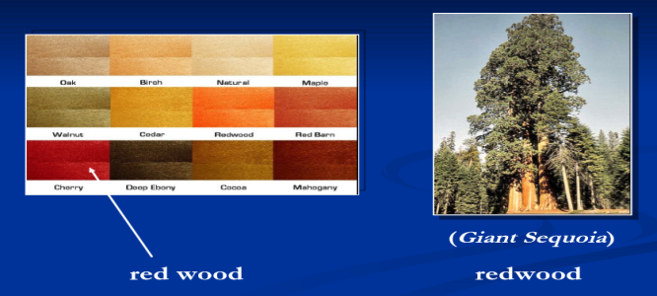***Example:***

**• Q 4: Can a word and morpheme be same.**

***Yes in some satiation the word and morpheme can be same.***

***Example: say , go , room ( it is word and as well as a morpheme)***

**• Q 5: Can we store all the possible variation of the root word in lexicon to avoid the morpheme analysis.?**

***No we cannot store the all possible root word in lexicon to avoid the morpheme analysis be the semantic and new word are avalleved with the time by the human being.***

***If we store the all the possible root word in the lexicon ,then in some situation the word have different semantic according to the sentence to understand that sentence by Natural language Processing System can wrong because the human can understand that sentence according to the current time and its semantic .***

***Example: I spring on the spring.***